Annexure

Disclosure of AI Usage in my Assessment

Section within the assessment in which generative AI was used:
- Concepting Feasibility
- Coding and Architecture Brainstorming
- Illustrative Art Asset generation
- Architectural implementation, coding and markdown file maintenance
- Documents in which AI was used:

Name of AI tool(s) used:
Codex: architectural design, coding, markdown file maintenance
ChatGPT: prompt engineering, brainstorming, and documentation refinement
Gemin And ChatGPT(Images 2.0): image generation

Purpose/intention behind use:
Assisting in the development of my LLM driven Game. As well as concept refinement and brief requirements. The documentation was finalised and assets were edit by me to ensure quality control.

Date(s) in which generative AI was used:
- 07 May 2026
- 11 May 2026
- 12 May 2026
- 13 May 2026
- 18 May 2026
- 20 May 2026
- 21 May 2026
- 22 May 2026

Evidence of AI usage:
Codex: Please see separate .txt files with the accessible chat history for the respective chats. (All chats done in 5.5 – Medium)
Gemini:
https://gemini.google.com/share/e9777128793c
Example of the prompt and output:
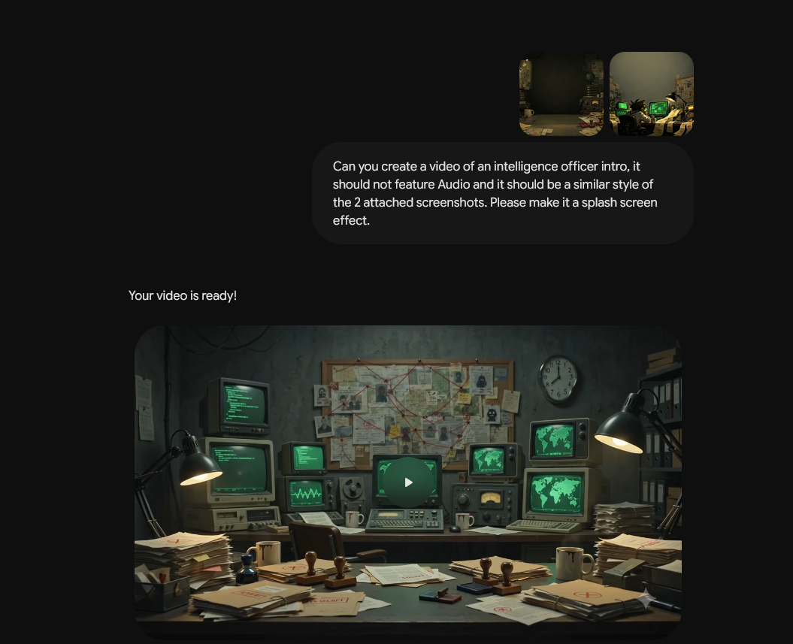
Chat GPT:
https://chatgpt.com/share/6a10b2ba-e374-83ea-a19e-c125420b6905
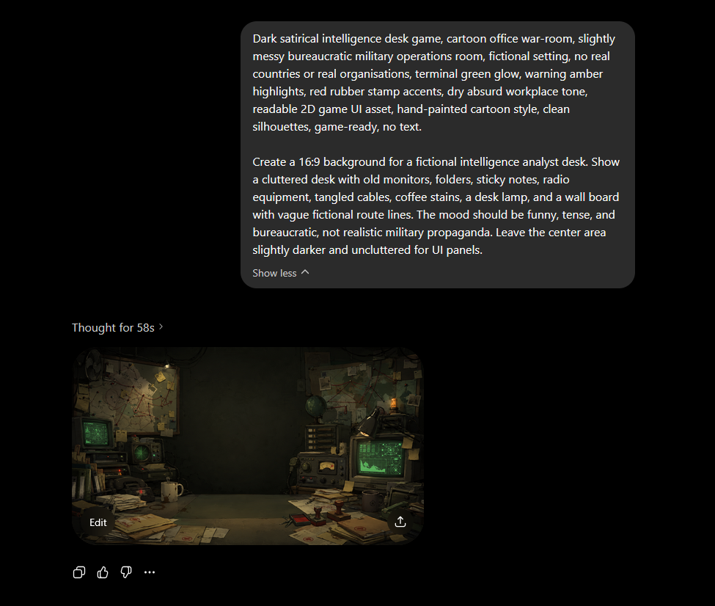
Brainstorming chat:
https://chatgpt.com/share/6a10b464-30dc-83ea-8c8a-82416f9fcacb

